Software Requirements and Design Document

for

<League Management System>

Prepared by <Muhammad Shehzad 20i-11756, Zeerak Zubair >

<League Informatica>

<27th November 2022>

Table of Contents

1. Introduction 3

1.1. Product Scope 3

1.2. Title 3

1.3. Objectives 3

1.4. Problem Statement 3

2. Overall Description 3

2.1 Product Perspective 4

2.2 Product Functions 4

2.3 List of Use Cases 4

2.4 Extended Use Cases 4

2.5 Use Case Diagram 5

3. Other Nonfunctional Requirements 5

3.1 Performance Requirements 5

3.2 Safety Requirements 5

3.3 Security Requirements 6

3.4 Software Quality Attributes 6

3.5 Business Rules 6

3.6 Operating Enviroment 6

3.7 User Interfaces 6

4. Domain Model 6

5. System Sequence Diagram 6

6. Sequence Diagram 6

7. Class Model 6

## Introduction

## Product Scope

We have chosen the Pakistan Super League as our scope. The current size of the PSL is scalable within our provided time frame. Our chosen management can be scaled to massive leagues such as IPL, EPL, Bundesliga, and La Liga Santander. However, to ensure that we can demonstrate our functionality, we have restricted ourselves to a smaller league.

## 1.2. Title

We have chosen to develop a League Management System to automate the scheduling of matches and provide statistical analysis of various teams in a league or a tournament.

## 1.3. Objectives

The primary goal is to provide an advanced League Management System, which can also be managed for a single purpose.

## 1.4. Problem Statement

Organizations such as PSL, IPL, UEFA, and ICC schedule leagues that are held for months approximately. We aim to automate the entire league process for such organizations to make a generic model, which can be applied to any major and minor sporting league.

There are certain aspects of a league, considering all sporting leagues. There are three main areas our company has identified:

1. League Administration
2. Team Administration
3. Spectators

According to our research, the aforementioned entities interact with each other during a whole length of a league.

Our League Management System will include the following features for cricket:

* + To record all teams and players.
  + To provide three views for each entity.
  + To enable team administration to view their respective team’s performance analytically.
  + To provide a rankings table.
  + To provide multiple match scheduling techniques.
  + To identify the best performing teams.
  + To provide match predictions.
  + To provide user polls based on public.
  + To provide venue details, such as reviews, etc.

## Overall Description

## 2.1 Product Perspective

The system is a new self-contained product.

## 2.2 Product Functions

It will perform the operations shown in the following use cases

## 2.3 List of Use Cases

1. Register Players
2. Register Teams
3. Register Coaches
4. Register Stadium/Venues
5. Register Stadium Staff
6. Schedule Matches
7. Manage (Record, Update, Delete) Matches
8. Record Match-Ball-By-Ball (ask someone)
9. Provide Commentary
10. Generate Statistics
11. Show Points Table
12. Give Report
13. Buy Ticket

## 2.4 Extended Use Cases

**1.. Register New Player**

|  |  |  |
| --- | --- | --- |
|  |  | |
| Use case name: | Register New Player | |
| Scope of the system under design | Pakistan Super League (PSL) | |
| Level | admin Level | |
| Primary Actor: | Team Administrator | |
| Stakeholder and Interests | * Team Administrator: Wants to register the correct details of players in the system. * Team Management: The team management wants to register the player’s details in their Team. | |
| Preconditions: | Team Administrator and team Management are Identified and authenticated. | |
| Postcondition: | 1. The player’s credentials are authenticated. 2. The system has recorded the details of the player. 3. The Team Management has received the confirmation for the inclusion of a player in the team. | |
| Main Success Scenario: | **Team Administrator** | **System Response** |
| 1.. The team management arrives at the Team Administrator’s office for the registration of the player.  2.. Team Administrator starts the registration of a player in the team.  4.. The team Administrator enters the details of the player | 3.. System asks for the details of the player  5.. System records the details of the player.  6.. The system sends a notification to the team administrator and team management |
| Extensions | **a\*** **At any time System Fails:**  To support recovery and correct registration, ensure all the transaction-sensitive states and events can be recovered from any step of the scenario.   1. Team administrator will restart the system, log in as a Team administrator, and request recovery of the prior state. 2. System reconstructs prior state.   **a1.The user logs in with incorrect credentials.**   1. The system will display “Incorrect Credentials.” 2. The user will be led to a prior case 3. The steps will be repeated until the correct credentials are entered.   **b\*** **The player is already registered:**  When the team administrator enters details of the player, the system will check if the player has already registered in any other team or not based on the details provided by the management.   1. The system will show the details of the player if they are registered for any other teams. 2. Team Administrator will tell the team management that the player has already registered in any other or this team.   **c\*** **The player details are not enough:**  When the team administrator enters details of the player that are not enough for the registration of the player.   1. The system will show that details are not enough for registration. 2. The team administrator will ask team management for more player details. | |

**2.. Register New Team**

|  |  |  |
| --- | --- | --- |
|  |  | |
| Use case name: | Register New Team | |
| Scope of the system under design | Pakistan Super League (PSL) | |
| Level | admin Level | |
| Primary Actor: | Team Administrator | |
| Stakeholder and Interests | * Team Administrator: Wants to register the correct details of team in the system. * Team Management: The team management wants to register the team details | |
| Preconditions: | Team Administrator is Identified and Authenticated. | |
| Postcondition: | * Team is registered with correct details. * The system has recorded the details of the Team. * The Team Management has received the confirmation for the registration of the team. | |
| Main Success Scenario: | **Team Administrator** | **System Response** |
| 1.. The team management arrives at the Team Administrator’s office for the registration of the player.  2.. Team Administrator starts the registration of team.  4.. Team Administrator enters the details of the team. | 3.. System asks for the details of the team.  5.. System records the details of the team.  6.. System sends a notification to the team administrator and team management. |
| Extensions | **a* At any time System Fails:**  To support recovery and correct registration, ensure all the transaction-sensitive states and events can be recovered from any step of the scenario.   1. Team administrator will restart the system, log in as a Team administrator, and request recovery of the prior state. 2. System reconstructs prior state.   **a1.The user logs in with incorrect credentials.**   1. The system will display “Incorrect Credentials.” 2. The user will be led to a prior case 3. The steps will be repeated until the correct credentials are entered.   **b* The team is already registered:**  When the team administrator enters details of the team, the system will check if the team has already registered or not based on the details provided by the management.   1. The system will show the details of the team if the team has registered. 2. Team Administrator will tell the team management that the team has already registered.   **c* The team details are not enough:**  When the team administrator enters details of the team that are not enough for the registration of the player.   1. The system will show that details are not enough for registration. 2. The team administrator will ask team management for more details. | |

**3.. Register Coaches:**

|  |  |  |
| --- | --- | --- |
|  |  | |
| Use case name: | Register New Coaches | |
| Scope of the system under design | Pakistan Super League (PSL) | |
| Level | admin Level | |
| Primary Actor: | System Administrator | |
| Stakeholder and Interests | * **System Administrator:** Wants to register the correct details of a coach in the system. * **Team Management:** The team management wants to register the coach details. | |
| Preconditions: | The system administrator and team management are identified and authenticated. | |
| Postcondition: | The coach is registered with the correct details.   * The system has recorded the details of the team. * The team Management has received the confirmation for the registration of the coach. | |
| Main Success Scenario: | **System Administrator** | **System Response** |
| 1.. The team management arrives at the system Administrator’soffice for the registration of the player.  2.. System Administrator starts the registration of the coach.  4.. System Administrator enters the details of the coach. | 3.. System asks for the details of the coach.  5.. System records the details of the team.  6.. System sends a notification to the system administrator and team management. |
| Extensions | **a* At any time System Fails:**  To support recovery and correct registration, ensure all transaction-sensitive states and events can be recovered from any step of the scenario.   1. System administrator will restart the system, log in as a System administrator, and request recovery of the prior state. 2. System reconstructs prior state.   **a1.The user logs in with incorrect credentials.**   1. The system will display “Incorrect Credentials.” 2. The user will be led to a prior case 3. The steps will be repeated until the correct credentials are entered.   **b* The coach is already registered:**  When the System administrator enters details of the coach, the system will check if the coach has already registered or not based on the details provided by the team management.   1. The system will show the details of the coach if the coach has registered. 2. System Administrator will tell the team management that the coach has already registered.   **c* The coach details are not enough:**  When the system administrator enters details of the coach that are not enough for the registration of the coach.   1. The system will show that details are not enough for registration. 2. The system administrator will ask team management for more details. | |

**4.. Register Stadium Staff:**

|  |  |  |
| --- | --- | --- |
|  |  | |
| Use case name: | Register New Stadium Staff | |
| Scope of the system under design | Pakistan Super League (PSL) | |
| Level | admin Level | |
| Primary Actor: | System Administrator | |
| Stakeholder and Interests | * **System Administrator:** Wants to register the correct details of staff in the system. | |
| Preconditions: | The system administrator are identified and authenticated. | |
| Postcondition: | * Staff is registered with correct details. * The system has recorded the details of the staff. * The Stadium Staff has received the notification for the registration of the team. | |
| Main Success Scenario: | **System Administrator** | **System Response** |
| 1.. The staff arrives at the system administrator’soffice for the registration of the player.  2.. System administrator starts the registration of staff.  4.. System administrator enters the details of the staff. | 3.. System asks for the details of the staff.  5.. System records the details of the staff.  6.. System sends a notification to the system administrator and staff. |
| Extensions | **a* At any time System Fails:**  To support recovery and correct registration, ensure all transaction-sensitive states and events can be recovered from any step of the scenario.   1. System administrator will restart the system, log in as a System administrator, and request recovery of the prior state. 2. System reconstructs prior state.   **a1.The user logs in with incorrect credentials.**   1. The system will display “Incorrect Credentials.” 2. The user will be led to a prior case 3. The steps will be repeated until the correct credentials are entered.   **b* The staff is already registered:**  When the System administrator enters details of the staff, the system will check if the staff has already registered or not based on the details provided by the staff.   1. The system will show the details of the staff if a team has registered. 2. System Administrator will tell the staff that he has already registered.   **c* The staff details are not enough:**   1. When the system administrator enters details of the staff that are not enough for the registration of the staff. 2. The system will show that details are not enough for registration. 3. The system administrator will ask team management for more details. | |

**5.. Register Stadiums:**

|  |  |  |
| --- | --- | --- |
|  |  | |
| Use case name: | Register New Stadiums | |
| Scope of the system under design | Pakistan Super League (PSL) | |
| Level | admin Level | |
| Primary Actor: | System Administrator | |
| Stakeholder and Interests | * **System Administrator:** Wants to register the correct details of stadium in the system. * **Stadium Management:** Wants to provide the correct details to the System Administrator. | |
| Preconditions: | The system administrator is identified and authenticated. | |
| Postcondition: | * Stadium is registered with correct details. * The system has recorded the details of the stadium. * The System administrator and the Stadium Management has received the notification for the registration of the stadium. | |
| Main Success Scenario: | **System Administrator** | **System Response** |
| 1.. The Stadium management arrives at the system Administrator’soffice for the registration of the stadium.  2.. The system Administrator starts the registration of the stadium.  4.. The system records the details of the stadium. | 3.. The system asks for the details of the stadium.  5.. The system records the details of the stadium.  6.. The system sends a notification to the system administrator. |
| Extensions | **a* At any time System Fails:**  To support recovery and correct registration, ensure all transaction-sensitive states and events can be recovered from any step of the scenario.   1. System administrator will restart the system, log in as a System administrator, and request recovery of the prior state. 2. System reconstructs prior state.   **a1.The user logs in with incorrect credentials.**   1. The system will display “Incorrect Credentials.” 2. The user will be led to a prior case 3. The steps will be repeated until the correct credentials are entered.   **b* The stadium is already registered:**  When the System administrator enters details of the stadium, the system will check if the stadium has already registered or not based on the details provided by the management.   1. The system will show the details of the stadium if the stadium has registered. 2. The system administrator will tell the management that it has already registered.   **c* The stadium details are not enough:**  When the system administrator enters details of the stadium that are not enough for the registration of the stadium.   1. The system will show that details are not enough for registration 2. The system administrator will ask management for more details. | |

**6.. Schedule Matches:**

|  |  |  |
| --- | --- | --- |
|  |  | |
| Use case name: | Schedule Matches | |
| Scope of the system under design | Pakistan Super League (PSL) | |
| Level | admin Level | |
| Primary Actor: | System Administrator | |
| Stakeholder and Interests | * Team: want to know who will they be playing against * Player: will want to know at what day, time and place will they be playing and against who. * Team Administrator: will want to know whom their team is playing against, at what time day, and place, they would want to manage their transportation in order to play against the opposing team in order to be present | |
| Preconditions: | The team’s and their respective administrator’s credentials must be authenticated. | |
| Postcondition: | The team administrator will be given a notification on the scheduled matches | |
| Main Success Scenario: | **System Administrator** | **System Response** |
| 1.. The admin will log into the system and open the Schedule Matches tab.  2.. The admin can view the registered teams.  5.. All of the team administrators will forward this message to their players.  6.. The admin will exit the system. | 3.. The system will prompt to select the desired format for the tournament schedule.  4.. The System will generate a notification that the league is prepared and the notification is sent to all participating team administrators. |
| Extensions | **a*. At any time, the system fails**   1. The admin will restart the system 2. logs in 3. requests recovery from prior state   **1a. admin’s credentials do not match at**  **login.**   1. The system will display “Incorrect Username and password” 2. Restart the system 3. Log in   **B*. The admin has not selected all of the**  **participating teams.**   1. The system will prompt the user to delete the new league. 2. After the user’s acknowledgement the system will delete the previous schedule. 3. The use case ‘Schedule Matches’ will be reinitiated | |

**7.. Manage Matches:**

|  |  |  |
| --- | --- | --- |
|  |  | |
| Use case name: | Manage Matches | |
| Scope of the system under design | Pakistan Super League (PSL) | |
| Level | admin Level | |
| Primary Actor: | System Administrator | |
| Stakeholder and Interests | Team Administrator: The System will want to know if any of the scheduled matches have been updated, deleted or rescheduled. | |
| Preconditions: | All of the teams and their administrators have been inducted into the system. Furthermore, the matches have been scheduled as well as initiated | |
| Postcondition: | The team administrator must be notified of any change initiated by the system. admin. | |
| Main Success Scenario: | **System Administrator** | **System Response** |
| 1.. The admin logs into the system.  2.. The admin views the ongoing and future scheduled matches.  4.. The admin selects the desired operation and it is executed.  6.. The admin logs out of the system. | 3.. The system will prompt on what operation should be performed on a match.  5.. The system generates a notification and sends it to the team administrators. |
| Extensions | **a*. At any time, the system fails**   1. The admin will restart the system 2. Logs in 3. Requests recovery from prior state   **1a. The admin logs into the system with**  **incorrect credentials**.   1. The system will display “Incorrect username and password” 2. Restart the system 3. Log in   **b*. The admin chooses to ‘delete’ a match**  **that is currently ongoing.**   1. The system will generate a notification “Cannot execute this command”. 2. The user will be led back to a prior state | |

**8.. View Ball-By-Ball Match Updates**:

|  |  |  |
| --- | --- | --- |
|  |  | |
| Use case name: | View Ball-By-Ball Match Updates | |
| Scope of the system under design | Pakistan Super League (PSL) | |
| Level | User Level | |
| Primary Actor: | System Administrator, Customer | |
| Stakeholder and Interests | * Customer: The Customer will want to know the status of the match. | |
| Preconditions: | The credentials must be authenticated, and the tournament must be scheduled and initiated beforehand | |
| Postcondition: | The customer or the team administrator must not log out of the system. | |
| Main Success Scenario: | **System Administrator** | **System Response** |
| 1.. The admin logs into the system.  3.. The admin will select the option ‘View ball-by-ball’ update  4.. The admin/user will view the match commentary and log out of the system. | 2.. System will verify the user.  3.. The system will show the update. |
| Extensions | **a*. At any time, the system fails**   1. The admin will restart the system 2. Logs in 3. Requests recovery from prior state.   **a1.The user logs in with incorrect credentials.**   1. The system will display “Incorrect Credentials.” 2. The user will be led to a prior case 3. The steps will be repeated until the correct credentials are entered. | |

**9.. Manage Commentary Panel**

|  |  |  |
| --- | --- | --- |
|  |  | |
| Use case name: | Manage Commentary Panel | |
| Scope of the system under design | Pakistan Super League (PSL) | |
| Level | admin Level | |
| Primary Actor: | System Administrator | |
| Stakeholder and Interests | Staff: The staff who will be required to provide live commentary on matches will be interested in any updates or changes made by the admin | |
| Preconditions: | The admin’s credentials must be authenticated | |
| Postcondition: | The staff must be informed if there are any changes made by the admin | |
| Main Success Scenario: | **System Administrator** | **System Response** |
| 1.. The admin logs into the system.  2.. The admin will select the option ‘Manage commentary Panel’.  4.. The admin will select the desired commentators for a match.  6.. The admin will agree with the confirmation message.  8.. The admin will log out of the system. | 3.. The system will show commentators.  5.. System will send a confirmation message to the admin.  7.. System will execute the specifications. |
| Extensions | **a*. At any time, the system fails**   1. The admin will restart the system 2. Logs in 3. Requests recovery from prior state   a1. The admin does not agree with the confirmation message.   1. The admin’s previous specifications will not be executed. 2. The admin will be led to a prior state of selection. 3. The admin will modify his/her selection. 4. The admin will acknowledge the confirmation. 5. The admin will exit the system.   a2. The admin wants to delete the previously chosen commentary panel.   1. The Amin will log into the system 2. The admin will select ‘modify commentary panel’ of a specific match. 3. The admin will be prompted to ‘delete current commentary panel’ 4. The admin acknowledges the command. 5. The system deletes the commentary panel. 6. The admin will be logged out of the system.   a3. The admin wants to change the previous chosen commentary panel.   1. The admin will log into the system. 2. The admin will select ‘change commentary panel’ of a specific match. 3. The admin will select the panel member to replace from the staff. 4. The admin will receive a confirmation message for the specified changes. 5. The admin will acknowledge the message. 6. The Specifications will be executed. 7. The admin will log out of the system. | |

**10.. Generate Statistics Report**

|  |  |  |
| --- | --- | --- |
|  |  | |
| Use case name: | Generate Statistics Report | |
| Scope of the system under design | Pakistan Super League (PSL) | |
| Level | admin Level | |
| Primary Actor: | System Administrator | |
| Stakeholder and Interests | * Team Administrator: The respective team administrators will be interested in viewing the tournament statistics at a specific time. | |
| Preconditions: | The admin’s credentials must be authenticated and validated | |
| Postcondition: | All of the team administrators must receive a notification of the generation of new statistics. | |
| Main Success Scenario: | **System Administrator** | **System Response** |
| 1.. The admin logs into the system.  3.. The admin will acknowledge the prompt.  6.. The admin will log out of the system | 2.. The system will prompt to select the ‘generate Statistics’.  4.. The system will send a confirmation message and generate the statistics.  5.. The generated statistics will be visible to team administrators. |
| Extensions | **a* At any time, the system fails**   1. The admin will restart the system 2. Logs in 3. Requests recovery from prior state   **a1.The user logs in with incorrect credentials.**   1. The system will display “Incorrect Credentials.” 2. The user will be led to a prior case 3. The steps will be repeated until the correct credentials are entered.   **b*.The generated statistics were not transmitted to the intended viewers.**   1. The team administrator complains to the admin. 2. The admin reinitiates the “Generate Statistics Report” use case. 3. The system ensures the report is viewable by the team admin. 4. The system sends a confirmation message to the team admin. 5. The process is repeated until the team admin acknowledges. | |

**11.. View Points Table**

|  |  |  |
| --- | --- | --- |
|  |  | |
| Use case name: | View Points Table | |
| Scope of the system under design | Pakistan Super League (PSL) | |
| Level | User Level | |
| Primary Actor: | Team Administrator and Customer | |
| Stakeholder and Interests | * Team Administrator: Interested to know if their team is the best performing team. * Player: Interested to know if they are among the best performing players. | |
| Preconditions: | The league has been initiated, and the team administrator and the customer must be logged into the system. | |
| Postcondition: | The points table must be viewable to all system users | |
| Main Success Scenario: | **Team Administrator**  **and Customer** | **System Response** |
| 1.. The Team administrator/ Customer will log into the system.  4.. The Team administrator/Customer will view and leave the system. | 2.. System will verify the details.  3.. System will prompt to view the points table. |
| Extensions | **a*. At any time, the system fails**   1. The customer will restart the system 2. Logs in 3. Requests recovery from prior state   **a1.The user logs in with incorrect credentials.**   1. The system will display “Incorrect Credentials.” 2. The user will be led to a prior case 3. The steps will be repeated until the correct credentials are entered. | |

**12.. Generate Match Report**

|  |  |  |
| --- | --- | --- |
|  |  | |
| Use case name: | Generate Match Report | |
| Scope of the system under design | Pakistan Super League (PSL) | |
| Level | admin Level | |
| Primary Actor: | System Administrator | |
| Stakeholder and Interests | * Team Administrator: Interested to know if their team is the best performing team. * Player: Interested to know if they are among the best performing players. | |
| Preconditions: | The admin’s credentials must be authenticated | |
| Postcondition: | The report must be transmitted to the Team admin and player. | |
| Main Success Scenario: | **System Administrator** | **System Response** |
| 1.. The admin logs into the system.  3.. Admin will select the match.  5.. Admin will select the report type.  7.. Admin will acknowledge the confirmation message.  9.. Admin and player will view the reports. | 2.. System verifies and prompt to select a match.  4.. System will prompt to generate reports of the match.  6.. System will send confirmation.  8.. System will generate the report. |
| Extensions | **a*. At any time, the system fails**   1. The admin will restart the system 2. Logs in 3. Requests recovery from prior state   **a1.The user logs in with incorrect credentials.**   1. The system will display “Incorrect Credentials.” 2. The user will be led to a prior case 3. The steps will be repeated until the correct credentials are entered.   **b*.The report is not viewable.**   1. The admin/player report that they cannot view the report. 2. The system will restart. 3. It will require the user to login. 4. If the report is still is not visible the system restart is repeated until. | |

**13.. Buy Ticket**

|  |  |  |
| --- | --- | --- |
|  |  | |
| Use case name: | Buy Ticket | |
| Scope of the system under design | Pakistan Super League (PSL) | |
| Level | User Level | |
| Primary Actor: | Customer | |
| Stakeholder and Interests | * System Administrator: Interested to know the percentage of seats sold. | |
| Preconditions: | The customer’s credentials must be authenticated. | |
| Postcondition: | The customer should be provided a digital copy for any transaction. | |
| Main Success Scenario: | **Primary Actor** | **System Response** |
| 1.. The customer logs into the system.  3.. Customer will select the match.  5.. Customer will select the seats.  7.. Customer will acknowledge the confirmation message.  9.. Customer will view the e-receipt and logout. | 2.. System verifies and prompt to select a match.  4.. System will display the available seats.  6.. System will send total cost and confirmation message.  8.. System will generate an e-receipt. |
| Extensions | **a*. At any time, the system fails**   1. The customer will restart the system 2. Logs in 3. Requests recovery from prior state   **a1.The user logs in with incorrect credentials.**   1. The system will display “Incorrect Credentials.” 2. The user will be led to a prior case 3. The steps will be repeated until the correct credentials are entered.   **b*. The customer wants to cancel their ticket**   1. The customer logs into the system 2. The customer will select the ticket to be cancelled 3. The system will generate a confirmation message 4. The customer will acknowledge the confirmation message 5. The system will prompt the customer to enter the preferred reimbursement method. 6. The customer will receive a digital receipt for the transaction. | |

## 2.5 Use Case Diagram

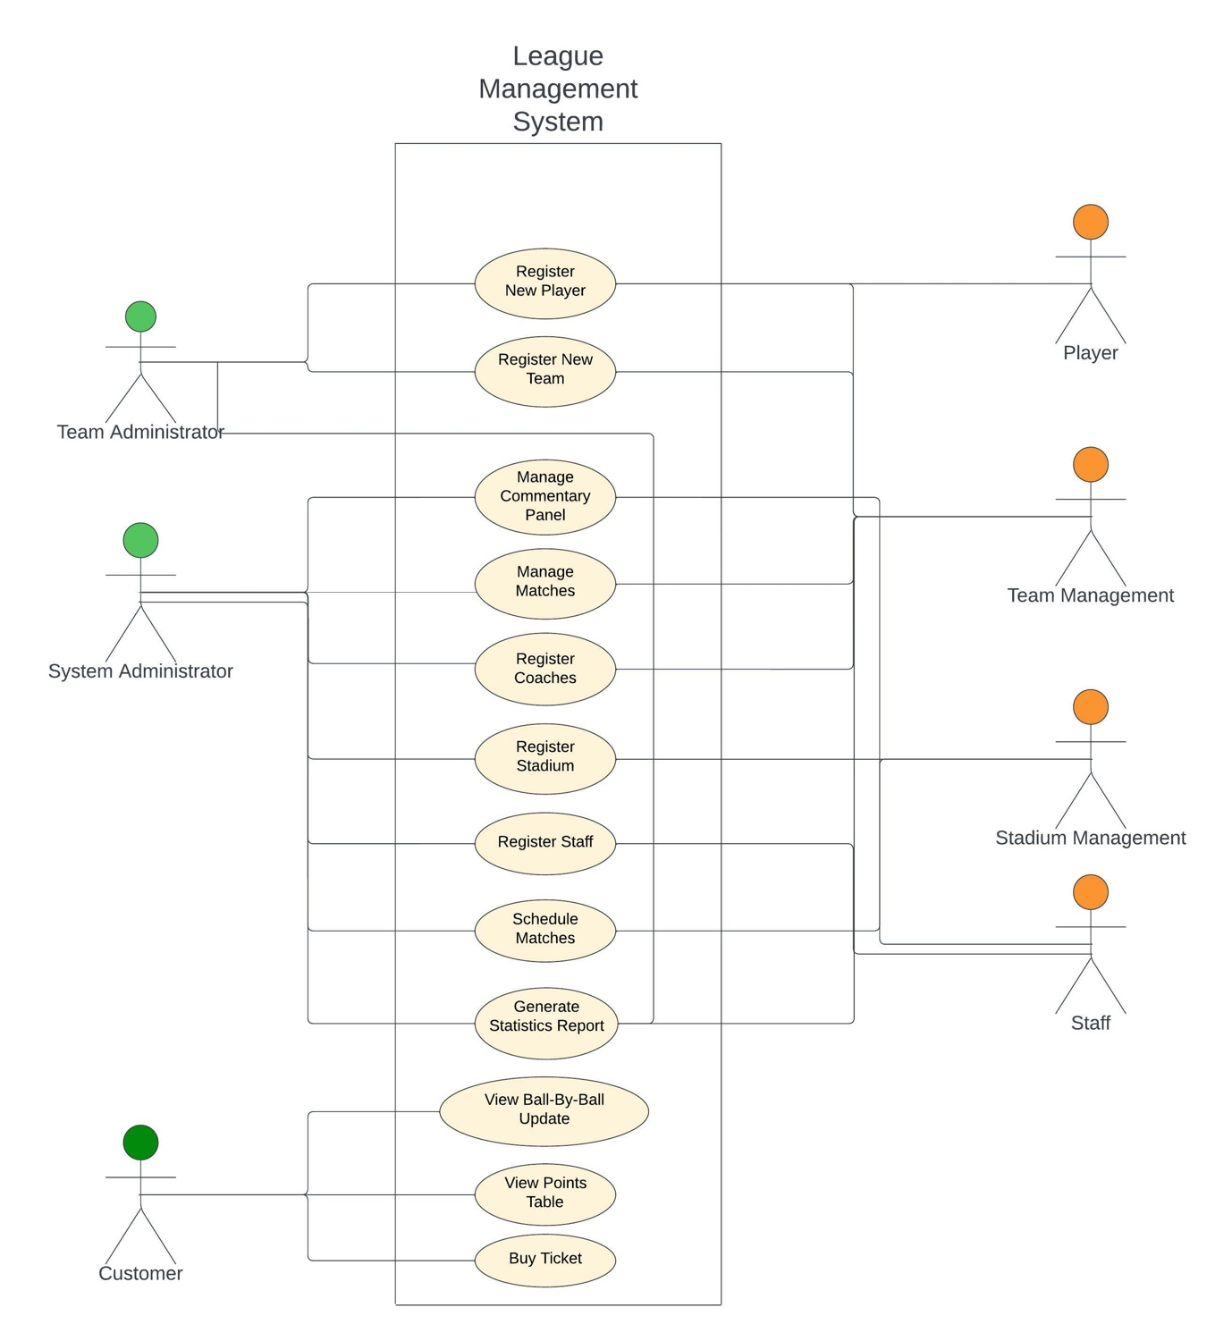

## Other Nonfunctional Requirements

## 3.1 Performance Requirements

No performance requirements

## 3.2 Safety Requirements

No safety requirements

## 3.3 Security Requirements

No security requirements

## 3.4 Software Quality Attributes

It is very cohesive as the GRASP patterns have been followed.

## 3.5 Business Rules

Please don’t copy this.

## 3.6 Operating Enviroment

This software can work in any machine containing JVM

## 3.7 User Interfaces

Multiple Interfaces are implemented for the User Interface

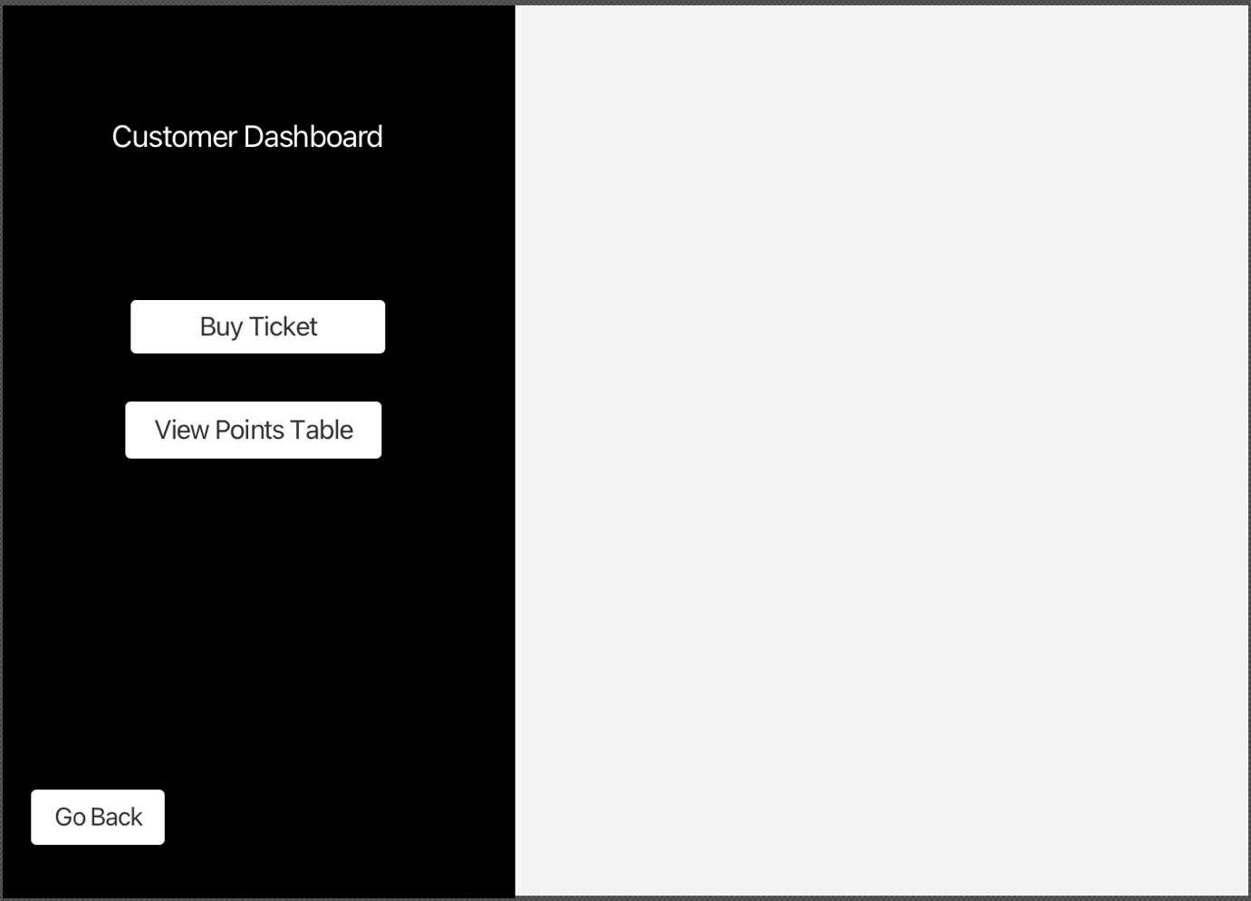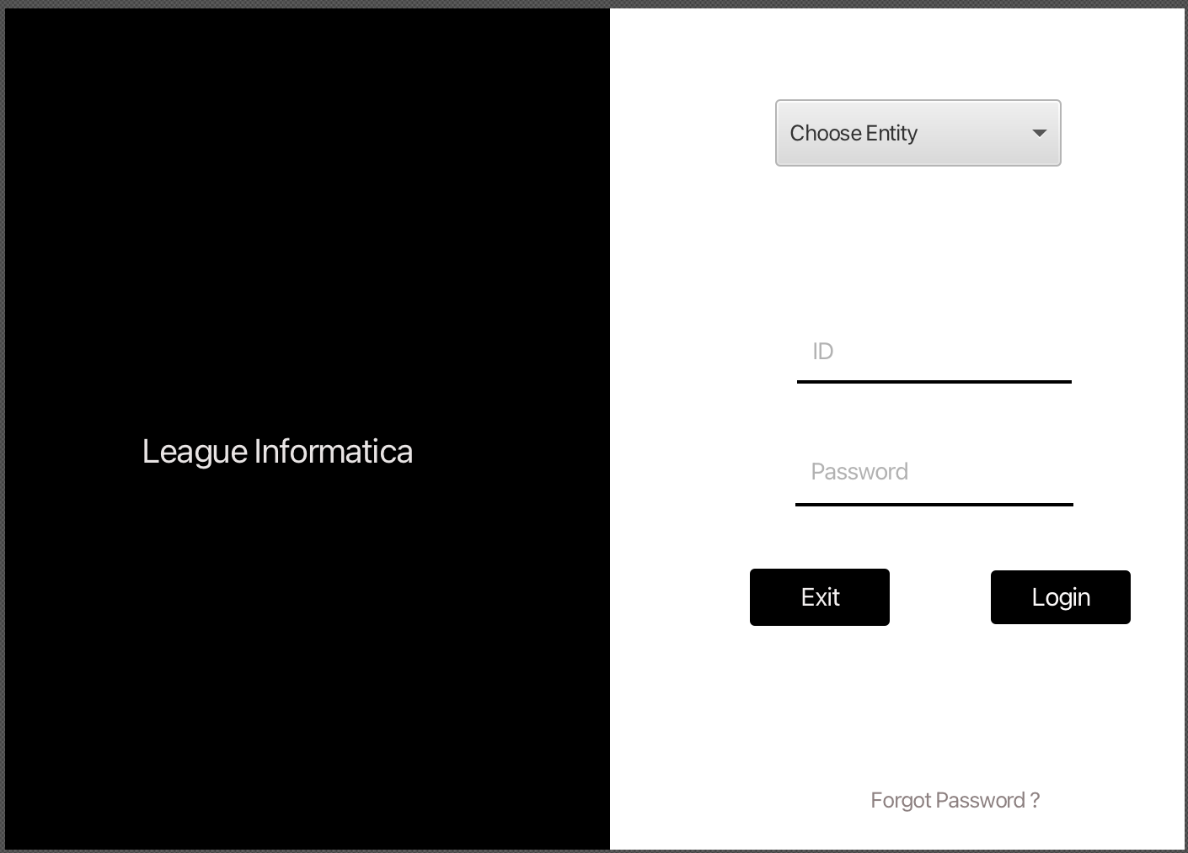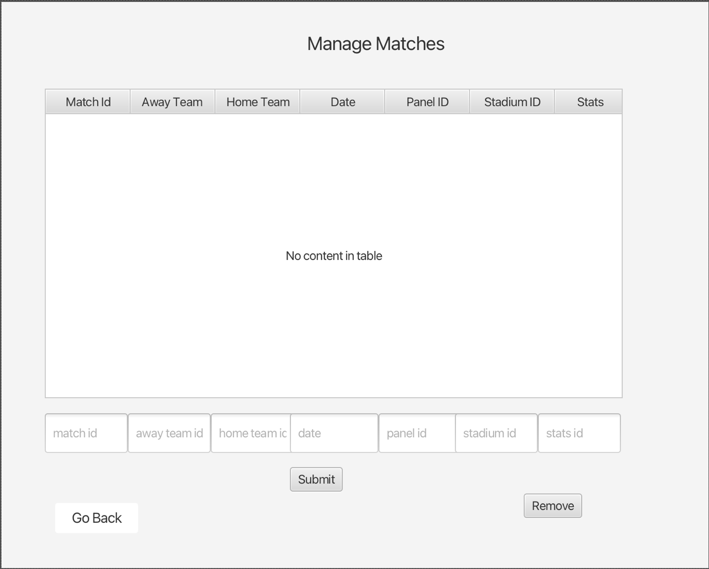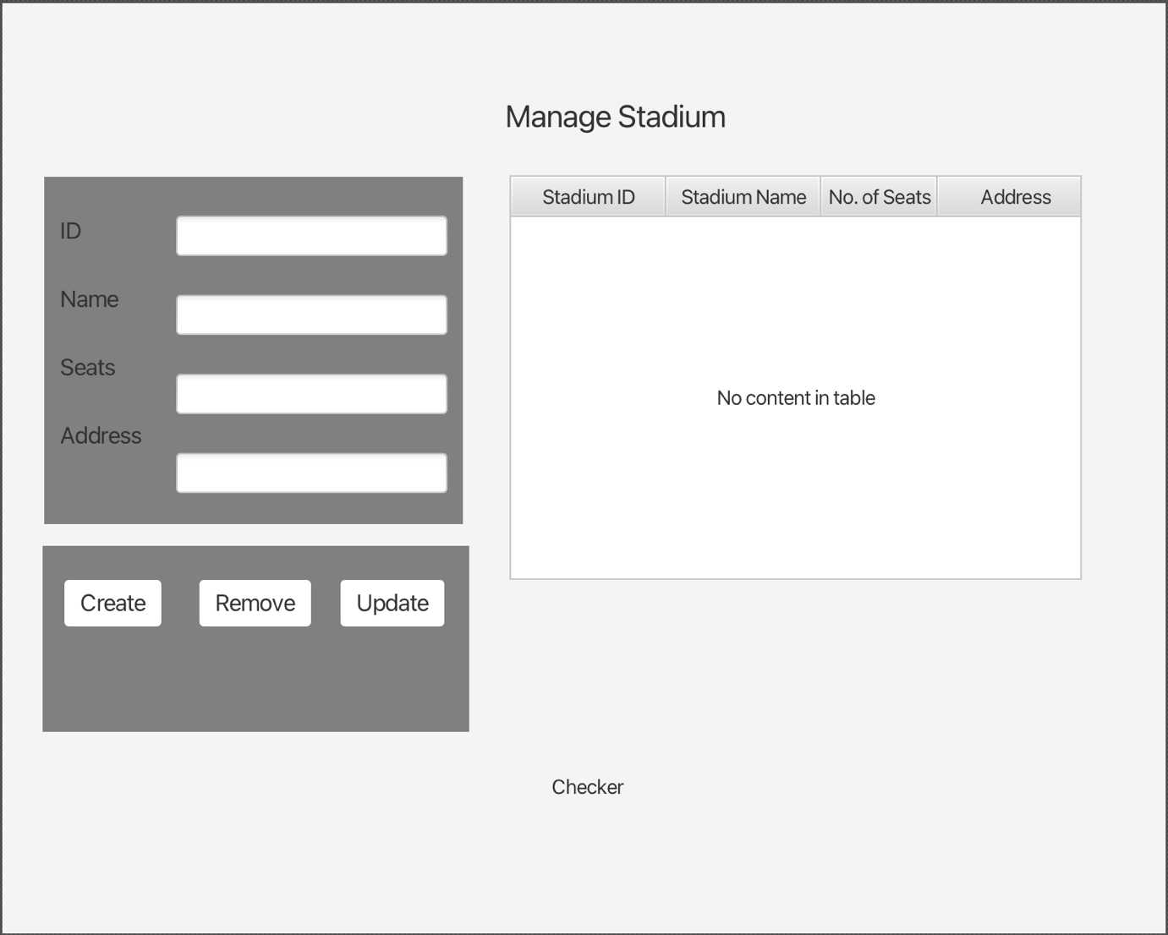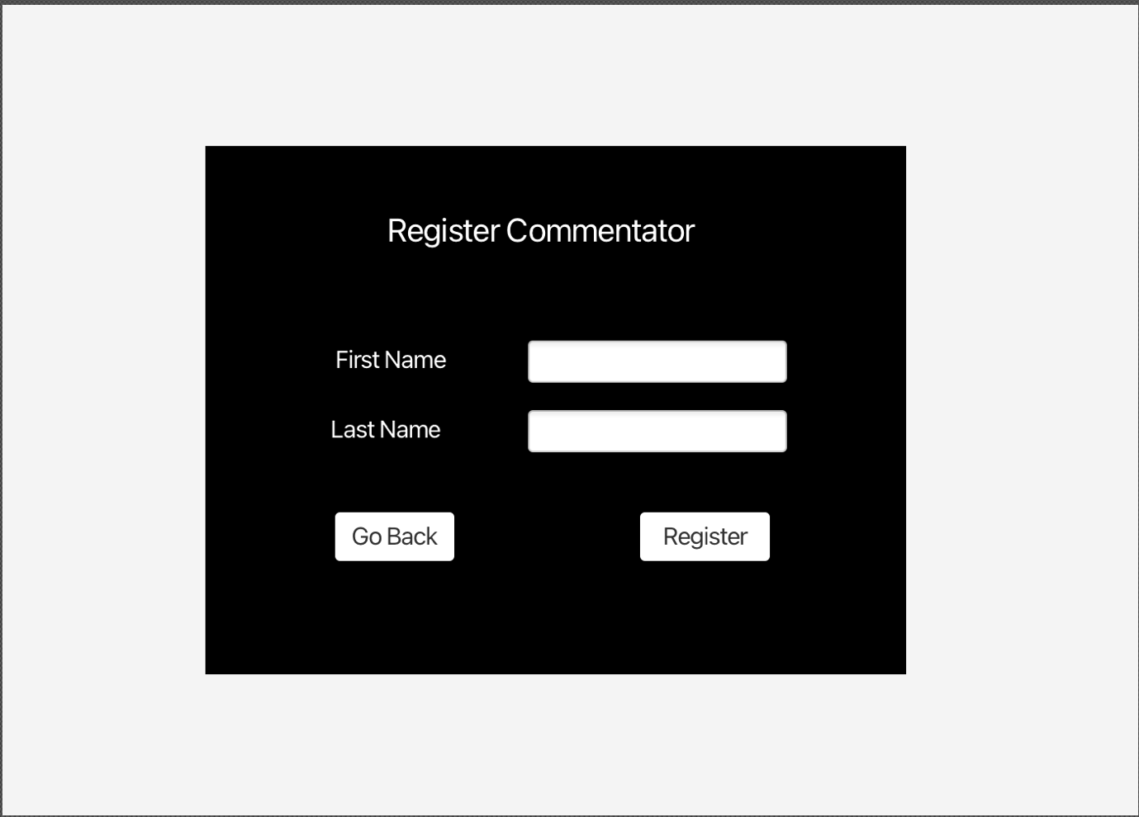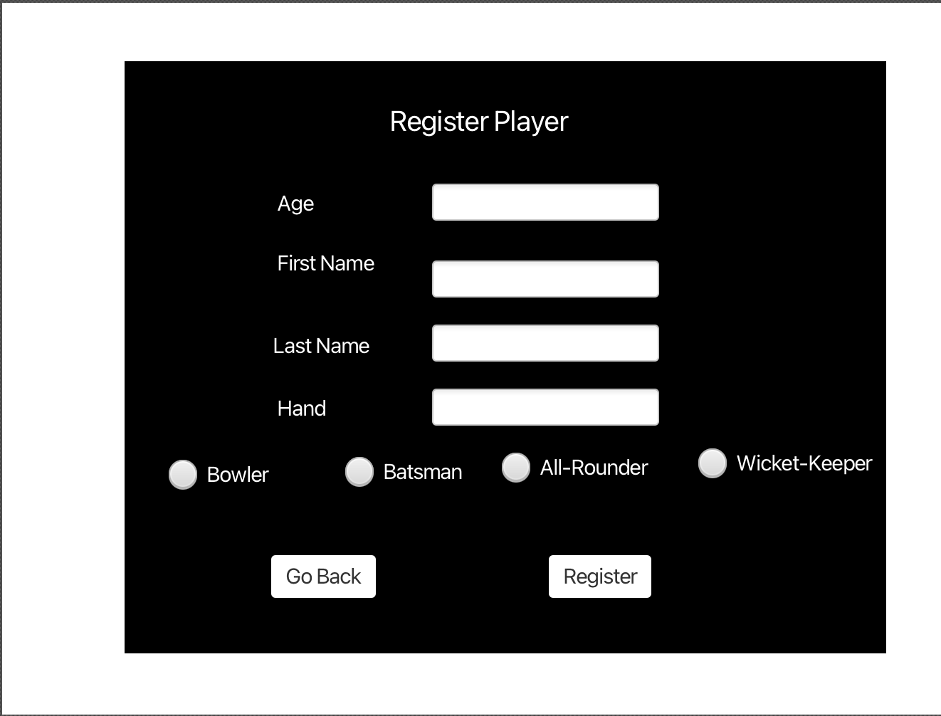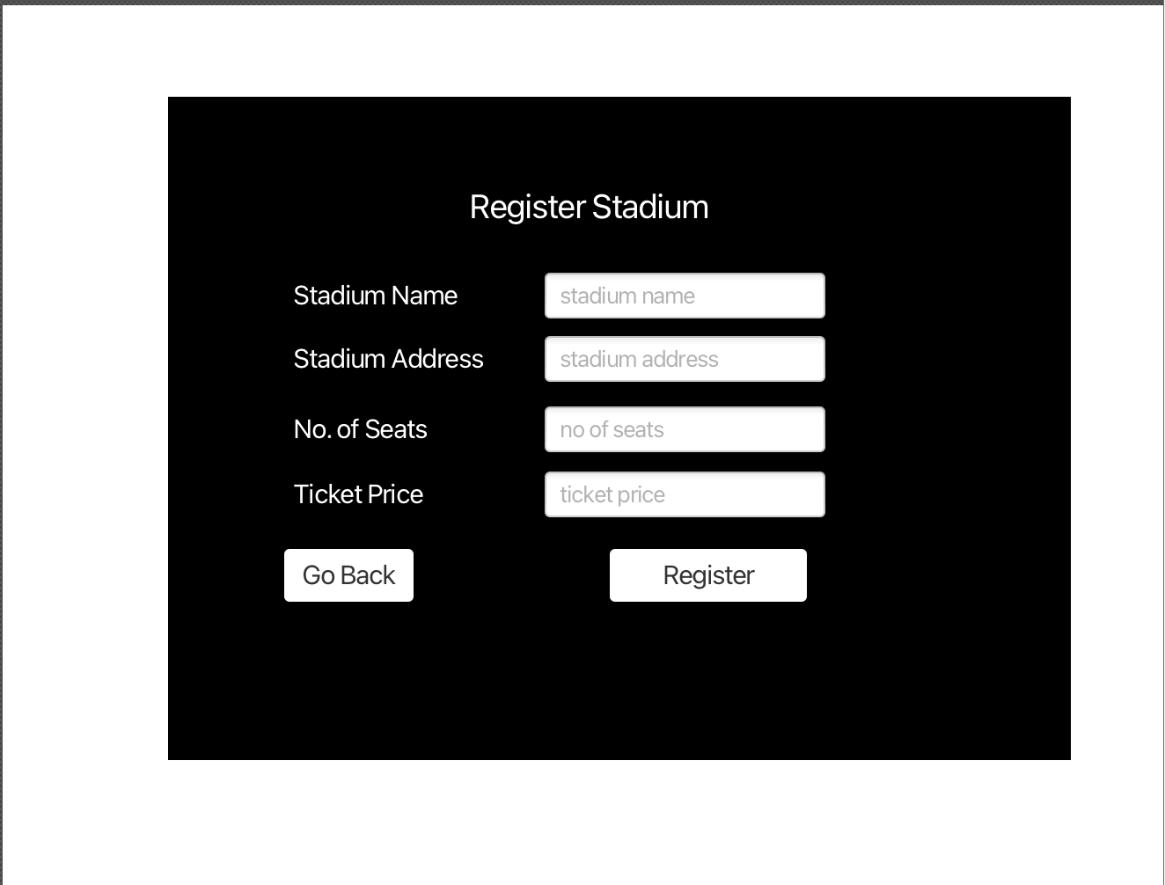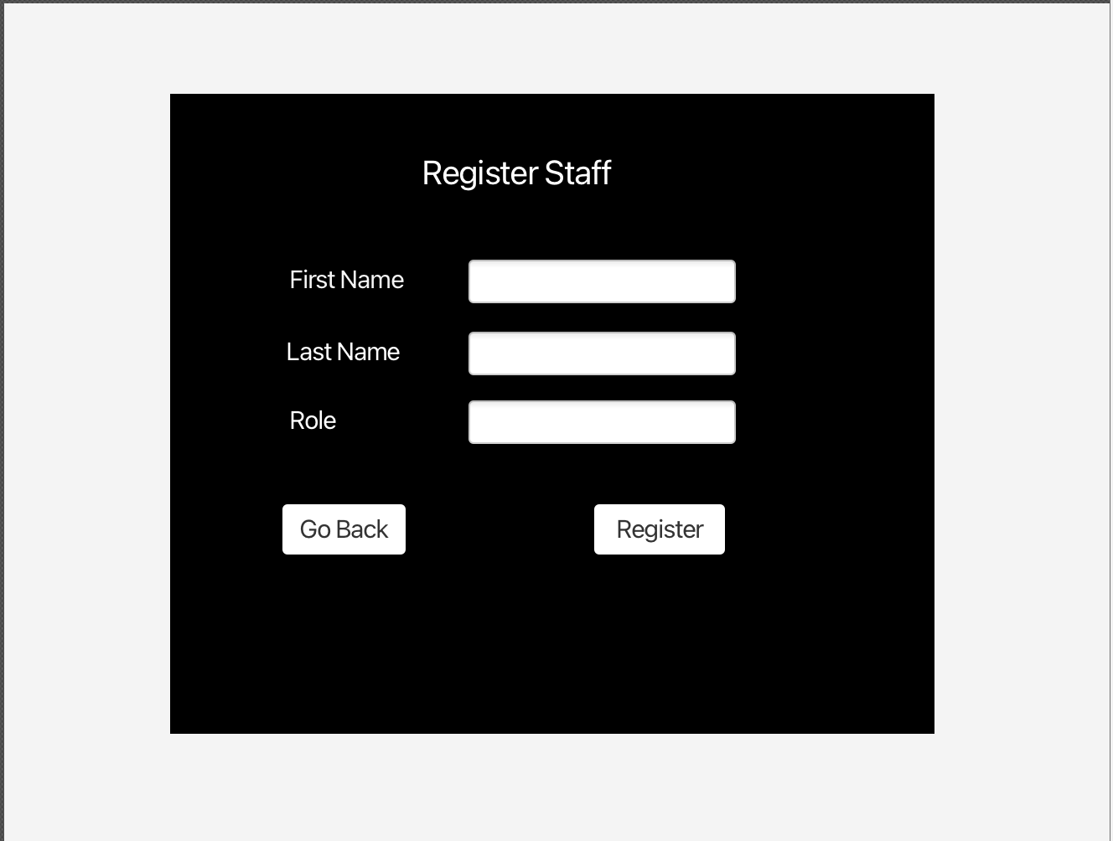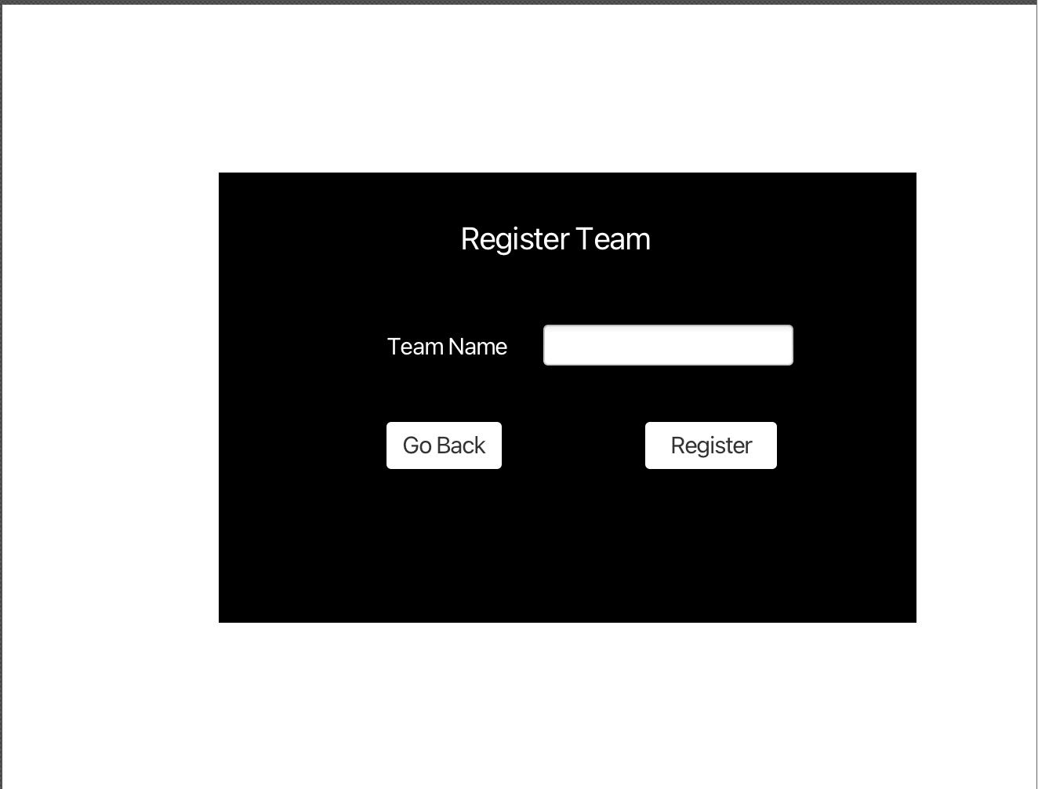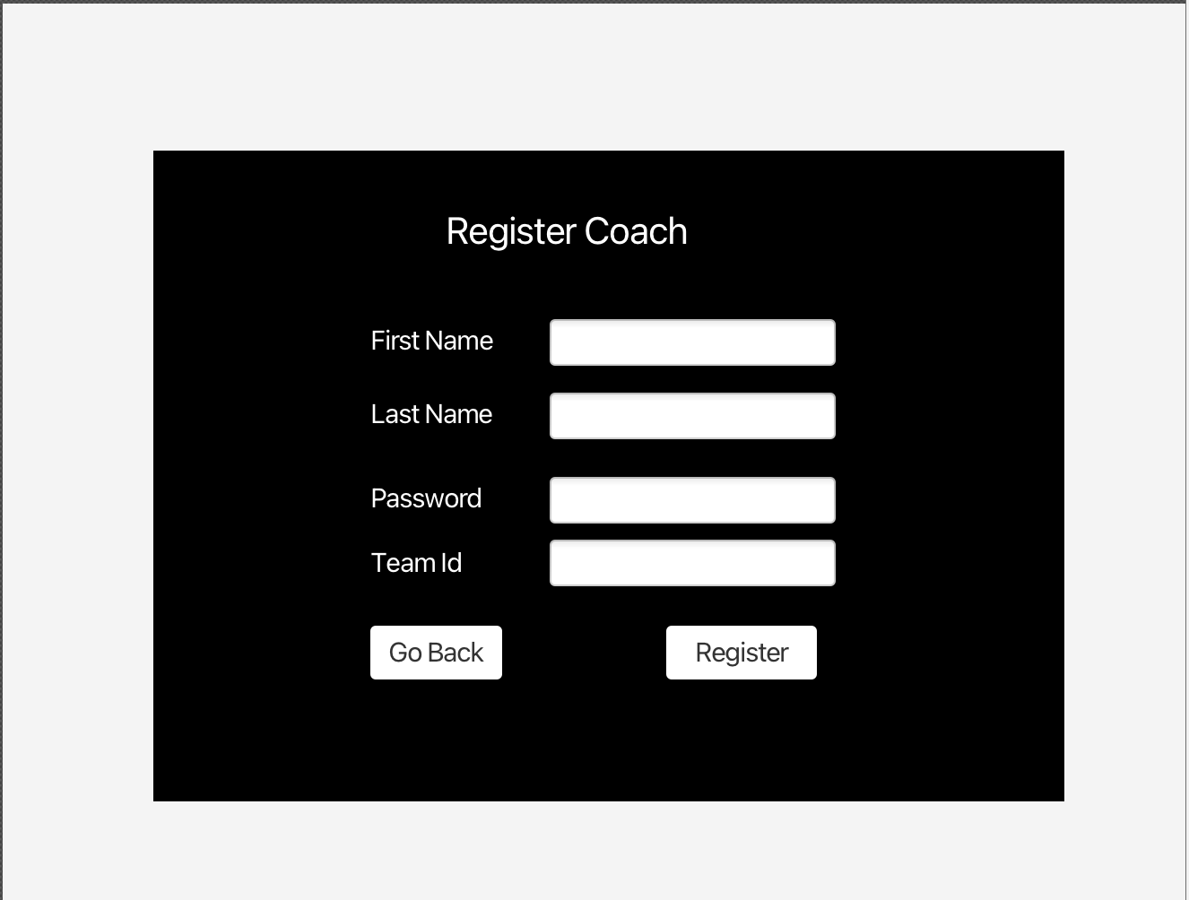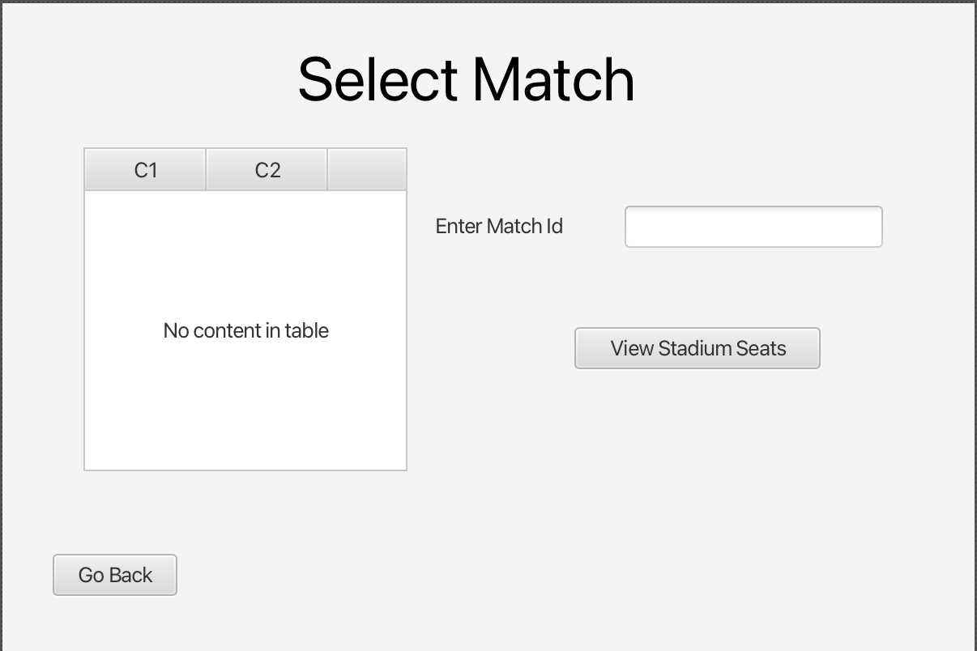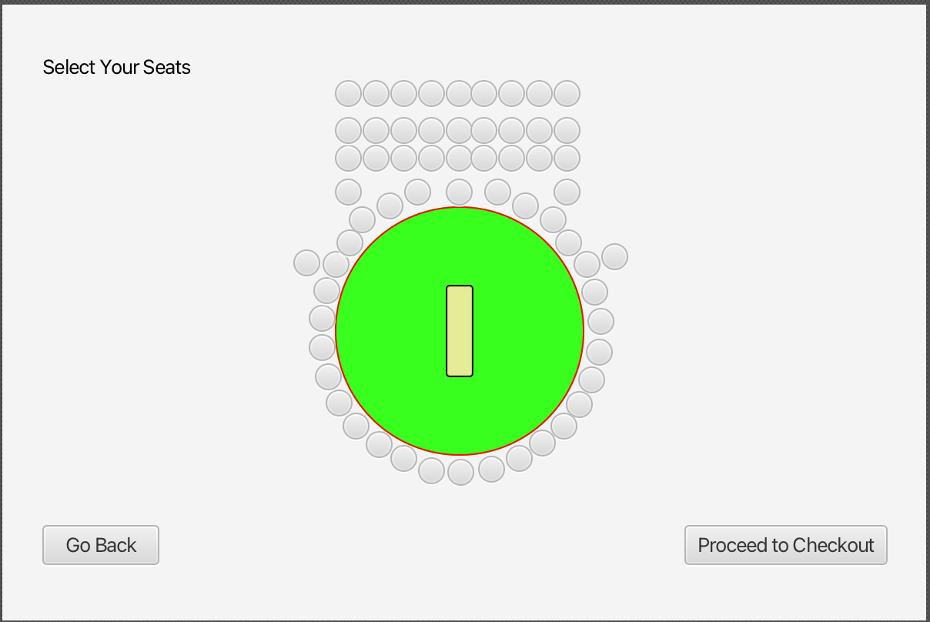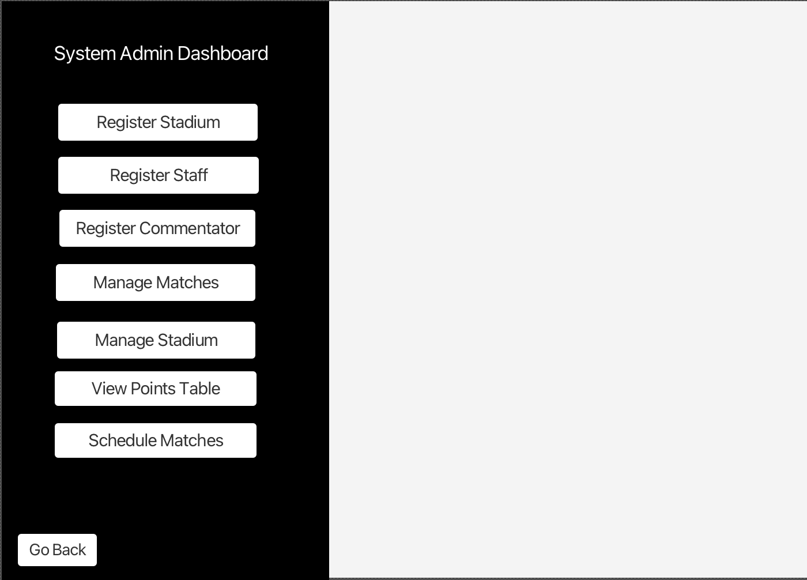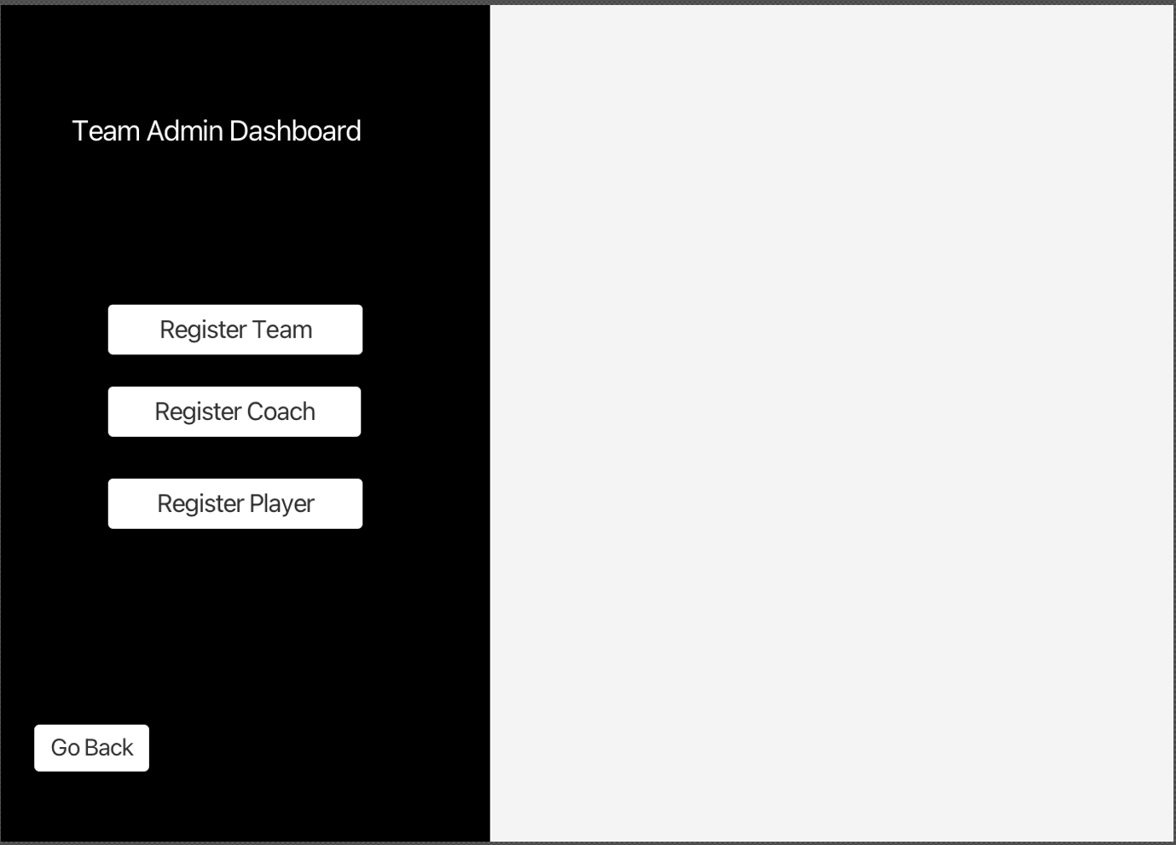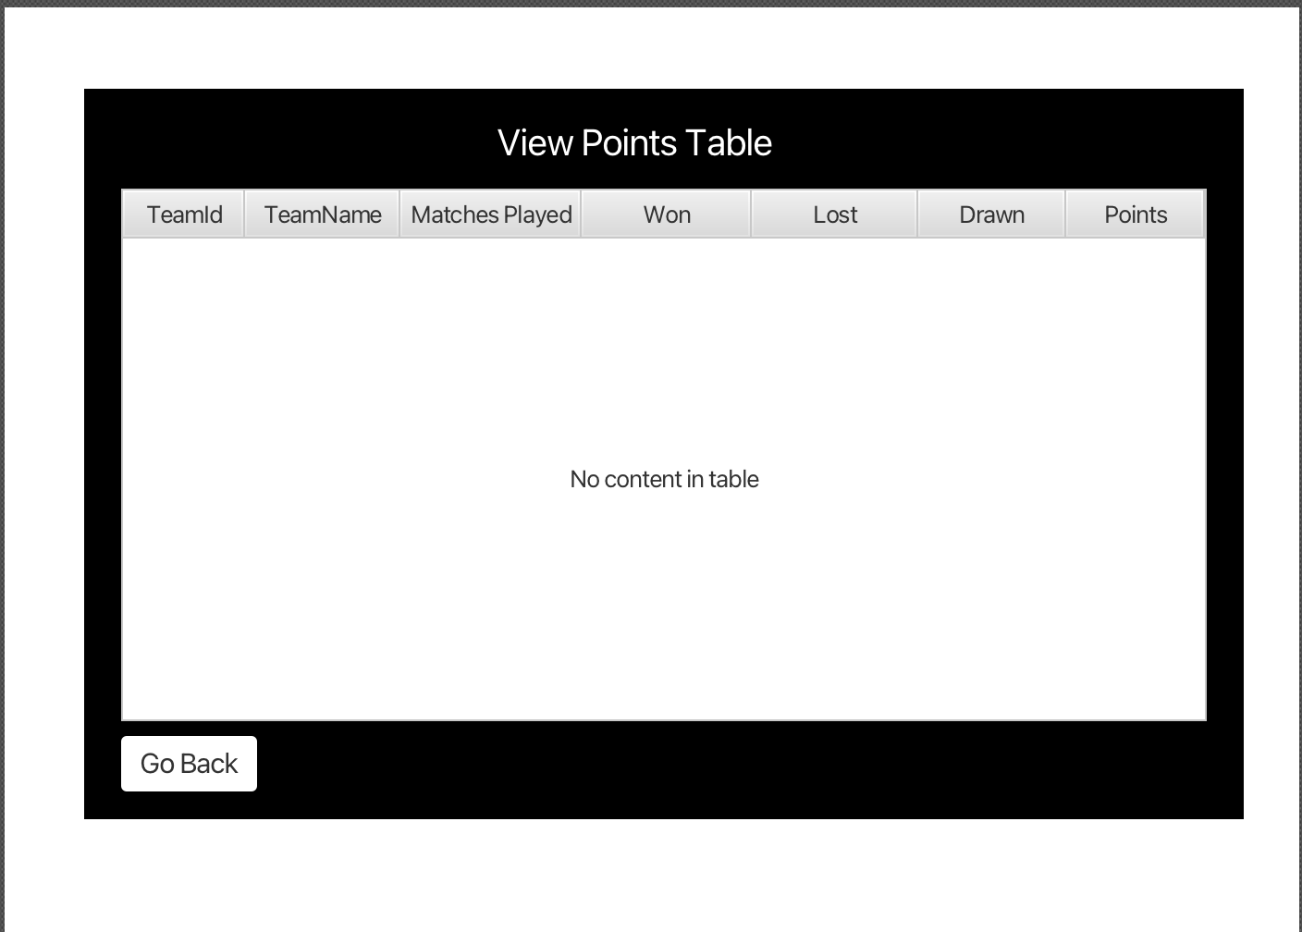

## Domain Model

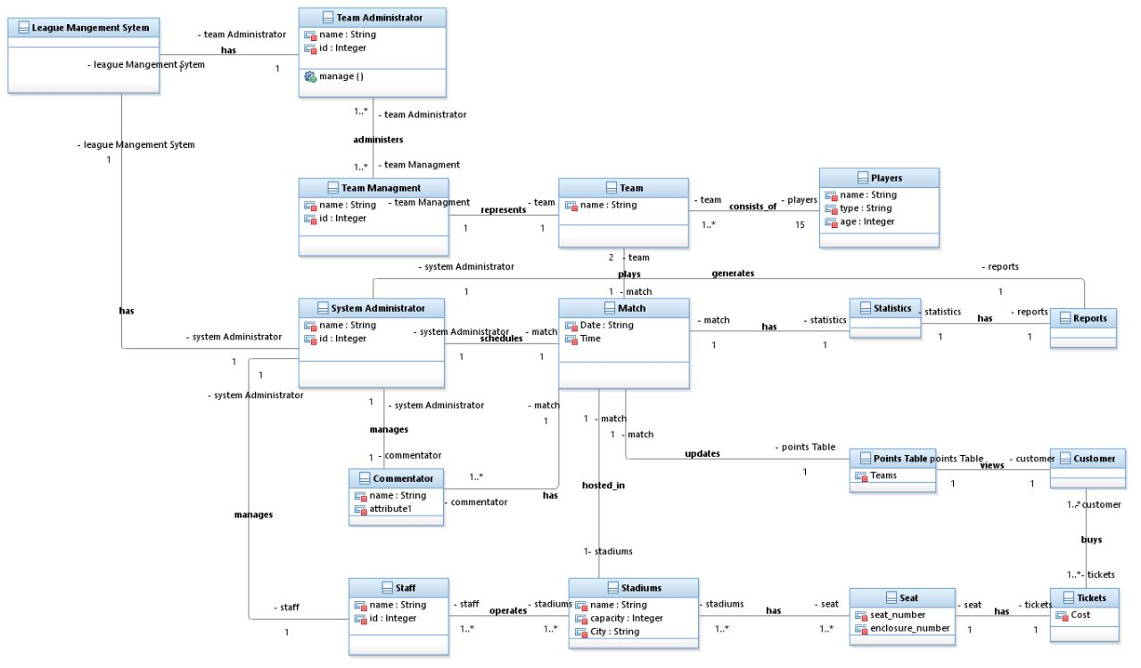

## Sequence Diagram

Register New Player

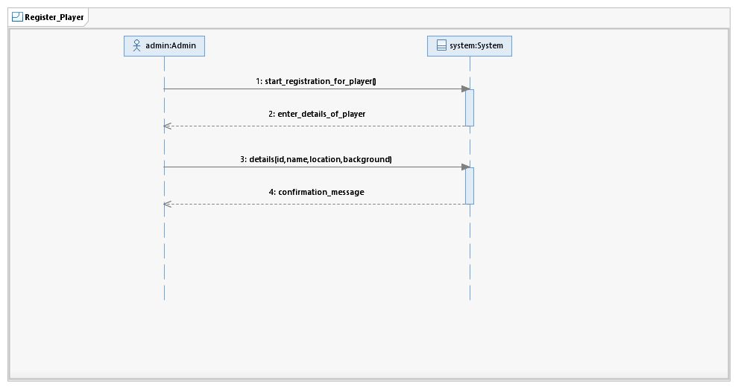

Register New Team

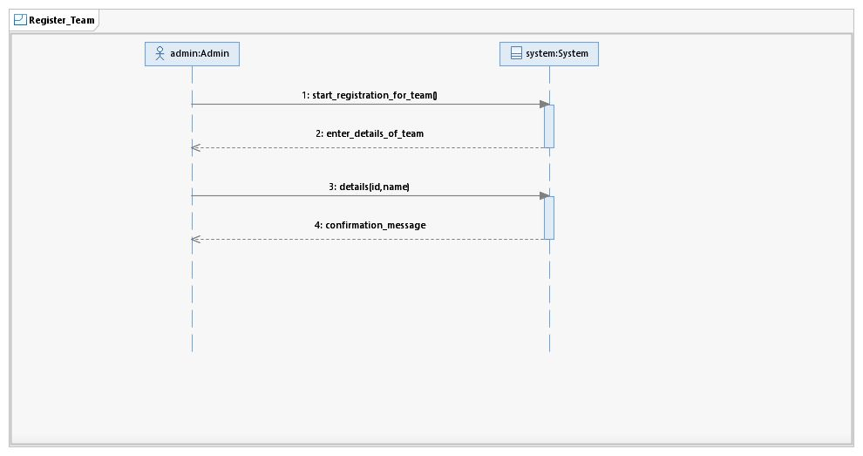

Register Coach

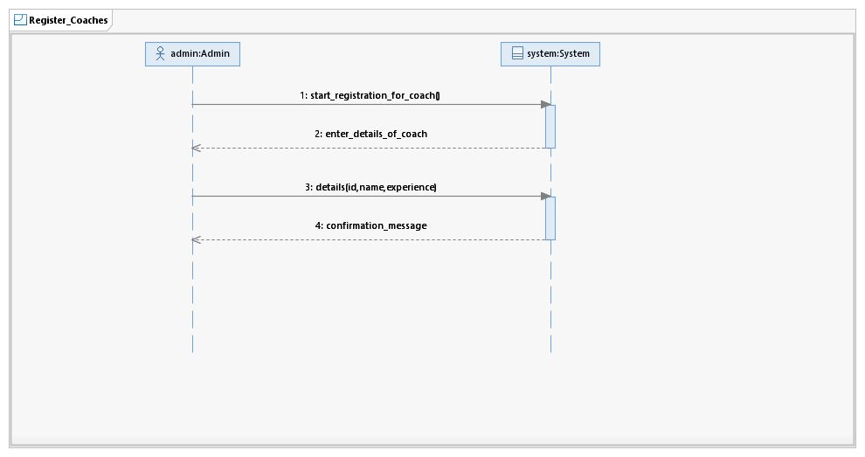

Register Stadium Staff

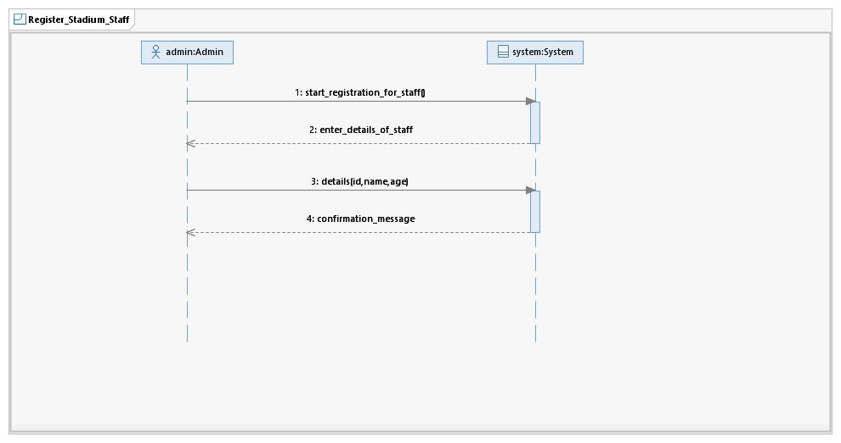

Register Stadium

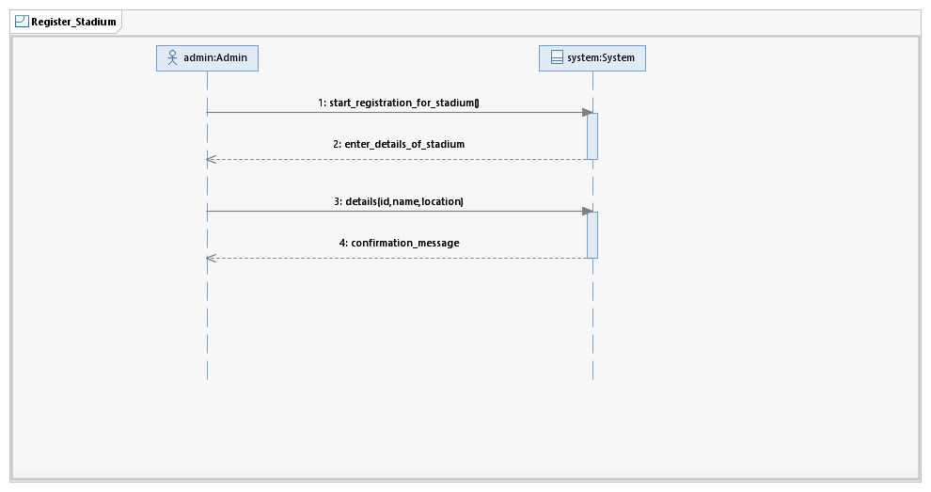

Schedule Matches

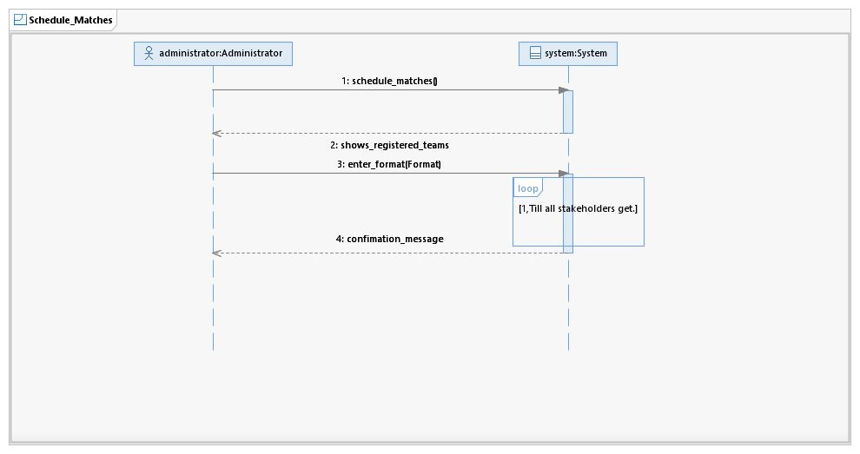

Manage Matches

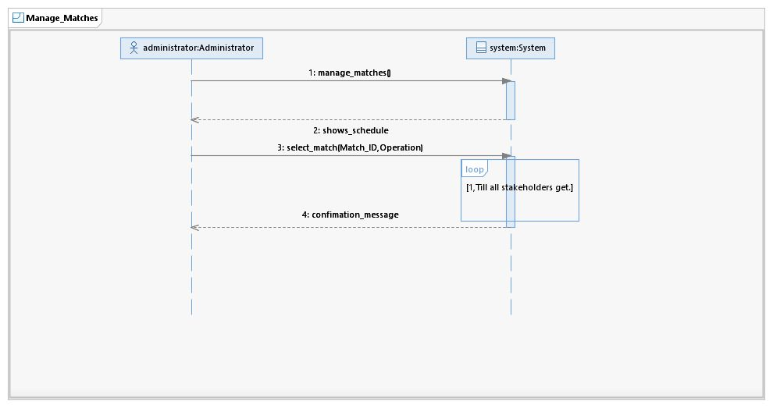

View Ball-by-Ball Updates

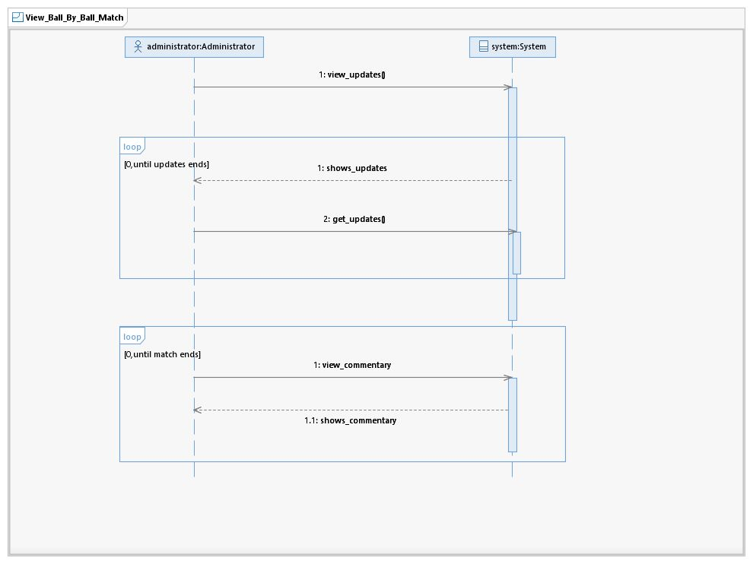

Manage Commentary Panel

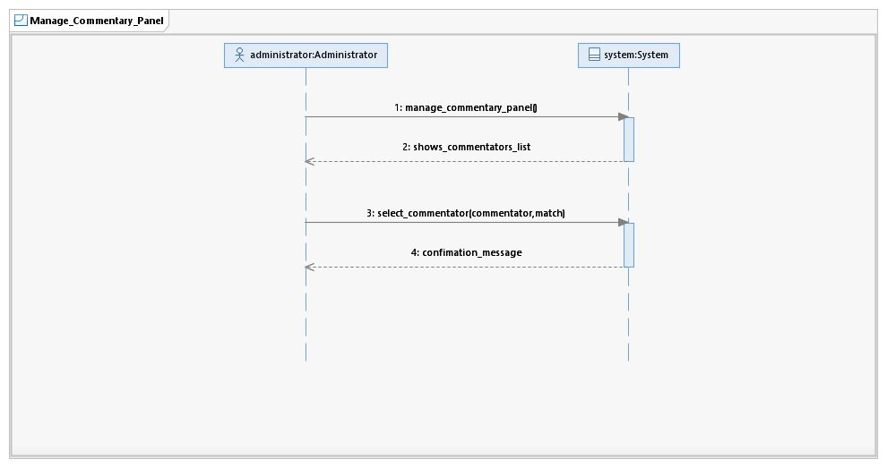

View Points Table

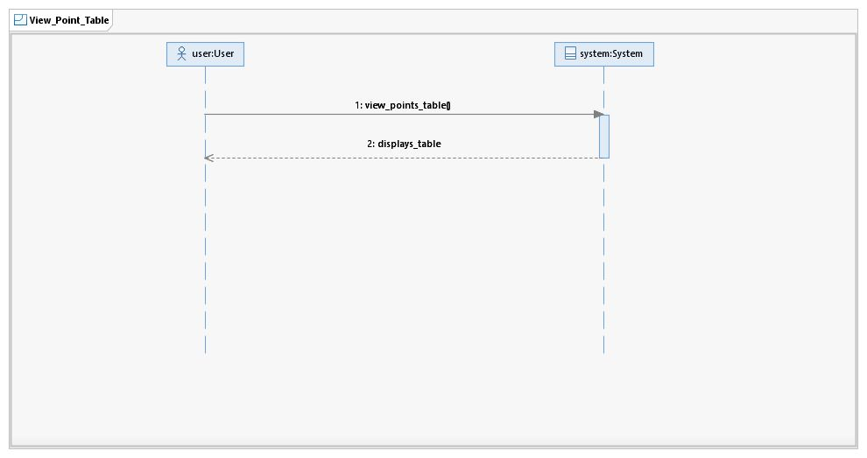

Buy Ticket

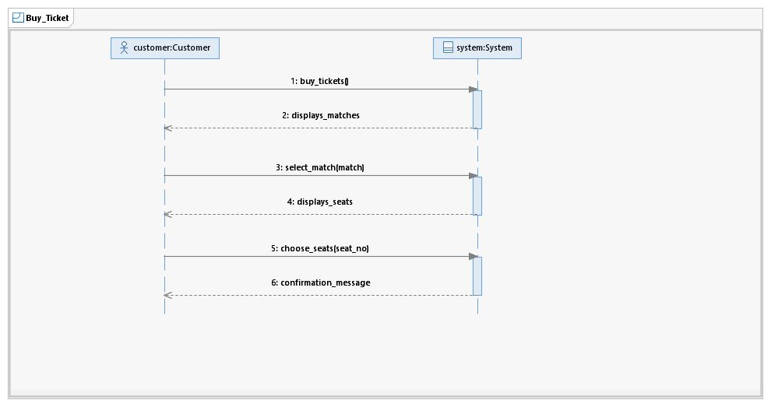

## System Sequence Diagram

# Register New Player

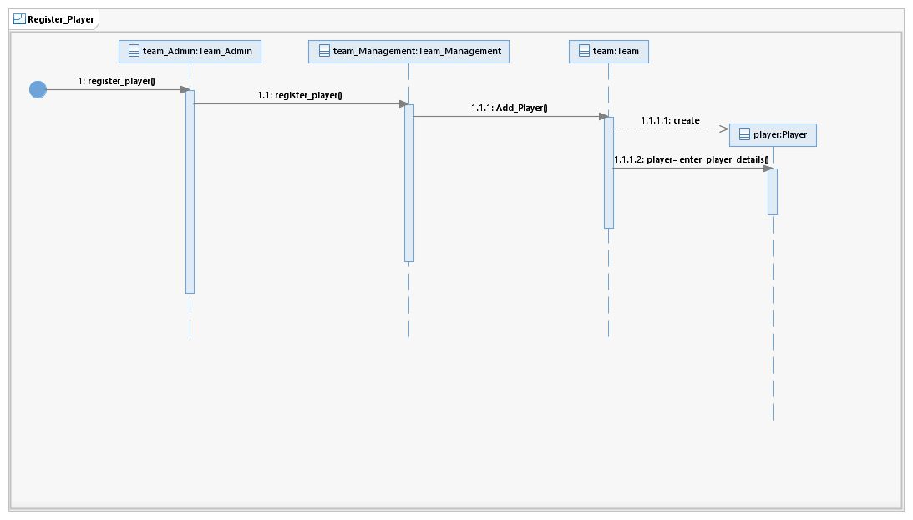

# Register New Team

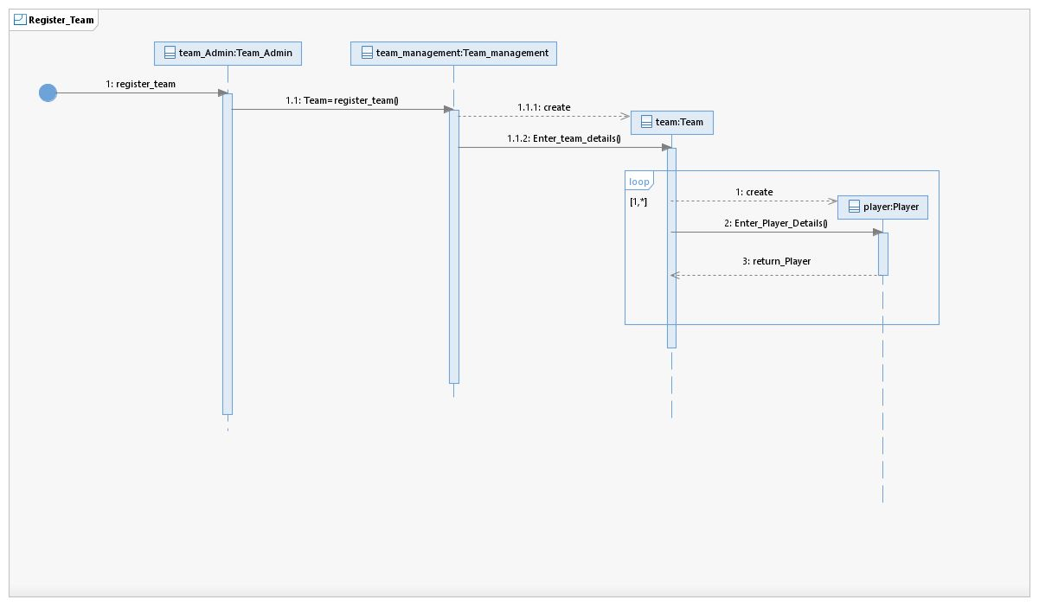

# Register Stadium Staff

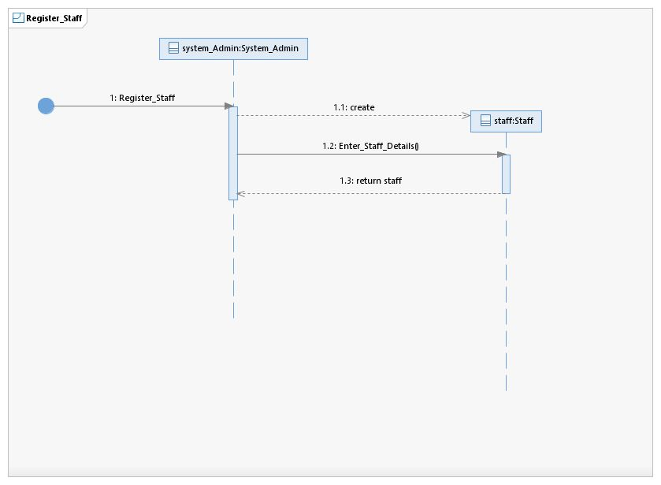

# Register Coaches

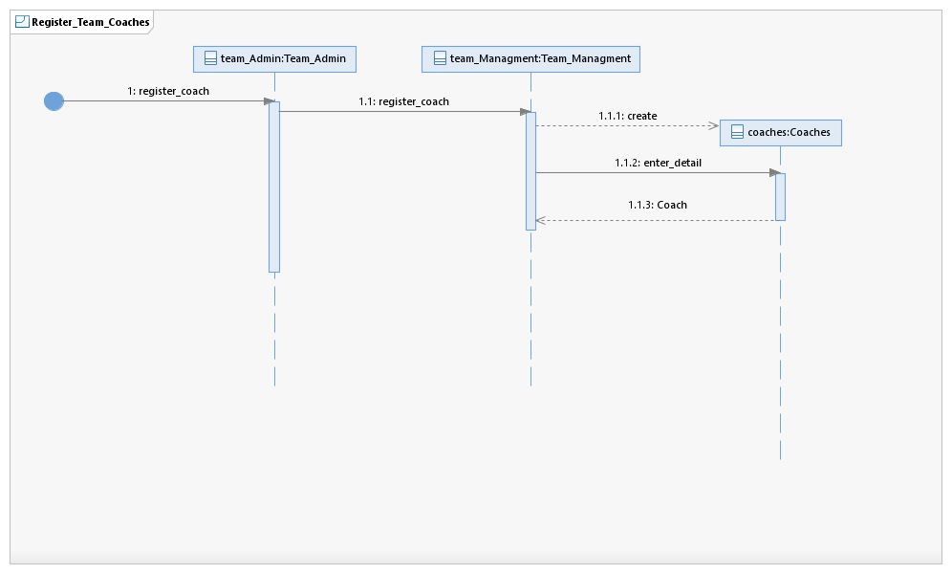

# Register Stadium

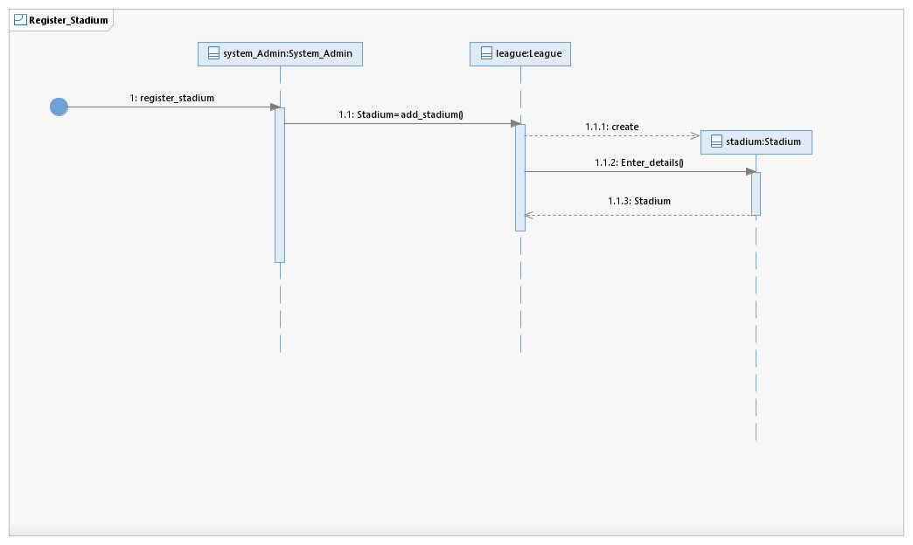

# Schedule Matches

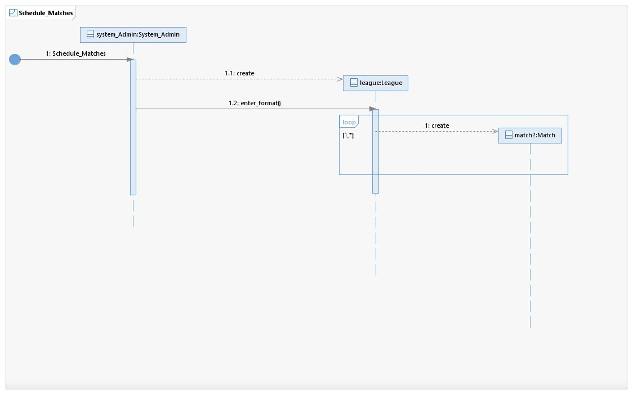

# Manage Matches

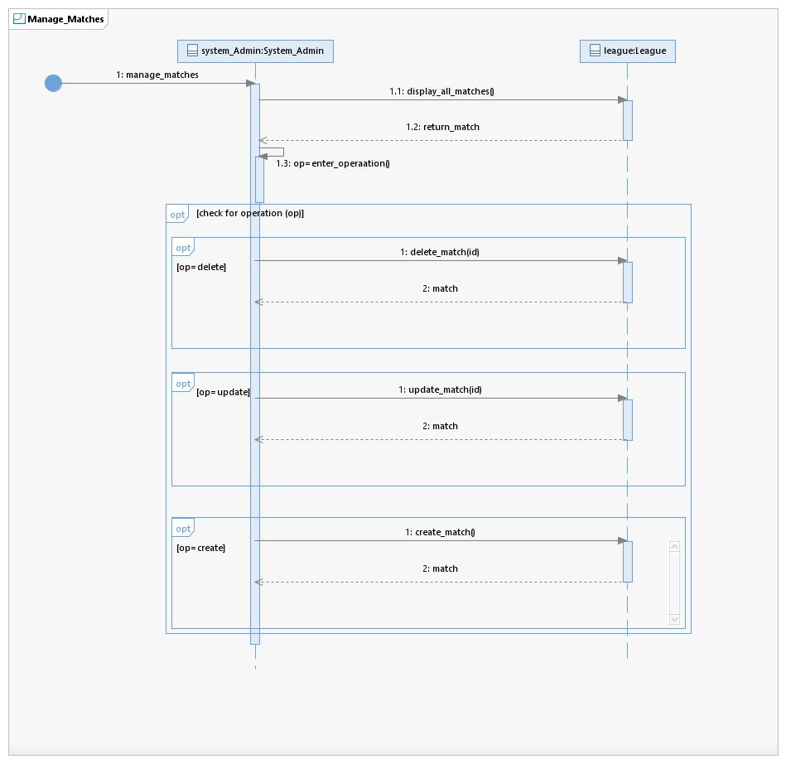

# View Ball-By-Ball Match Updates

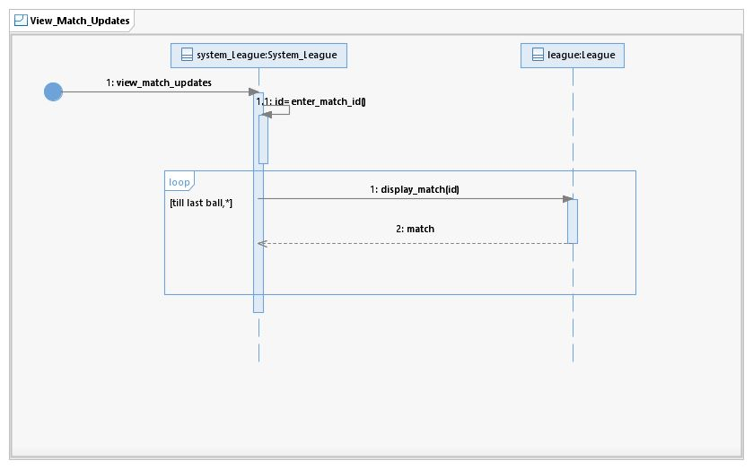

# Manage Commentary Panel

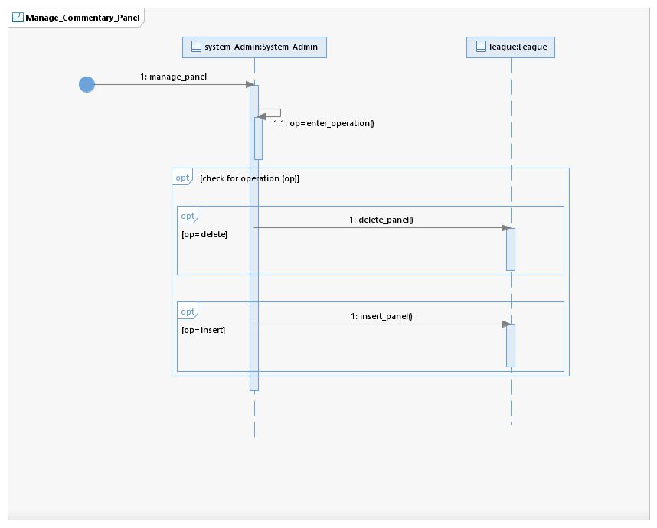

# Generate Statistics Report

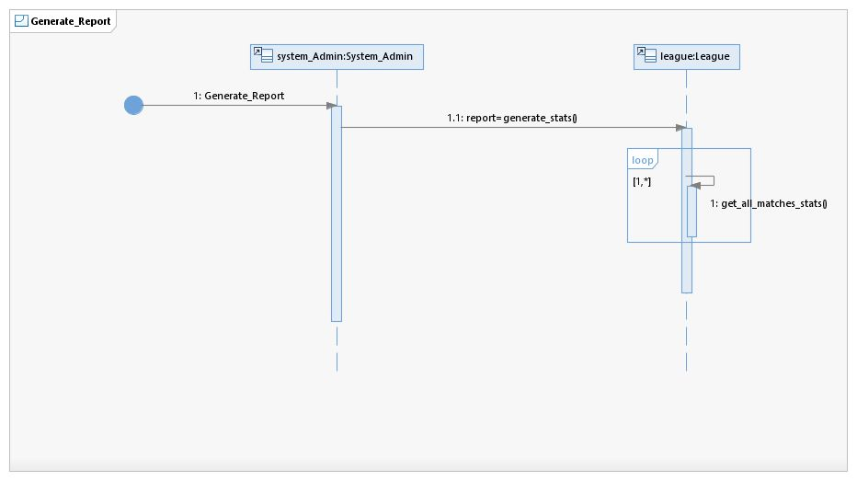

# View Points Table

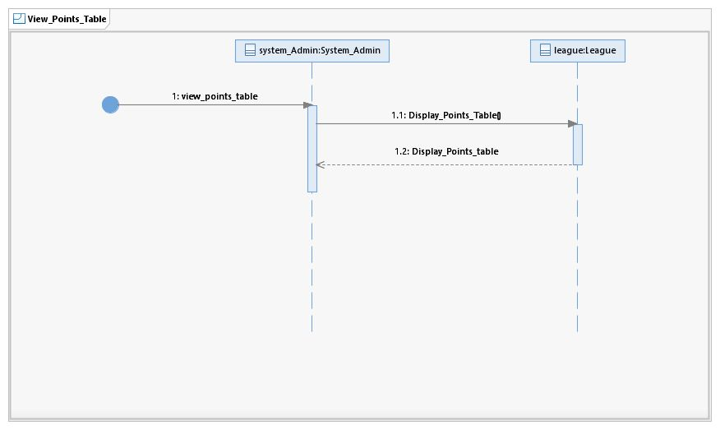

# Generate Match Report

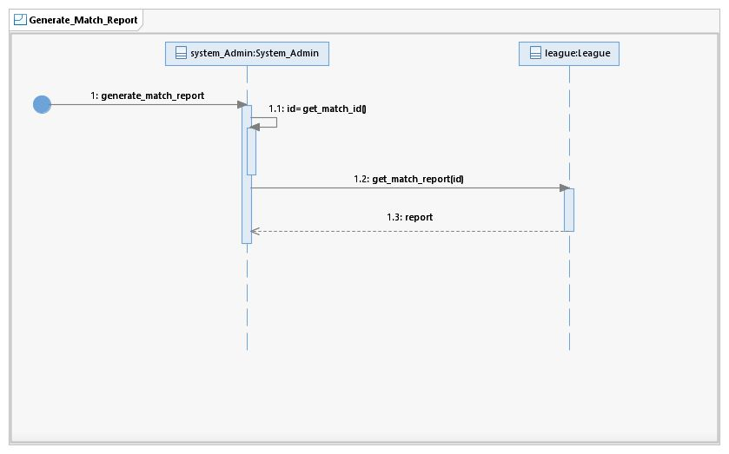

# Buy Ticket

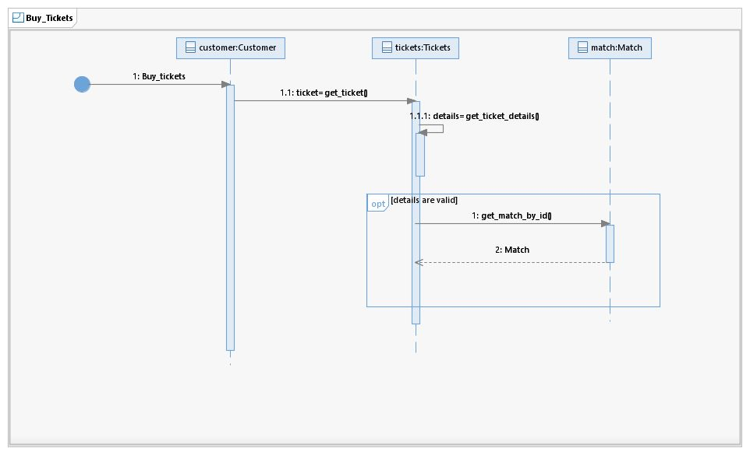

## Class Diagram

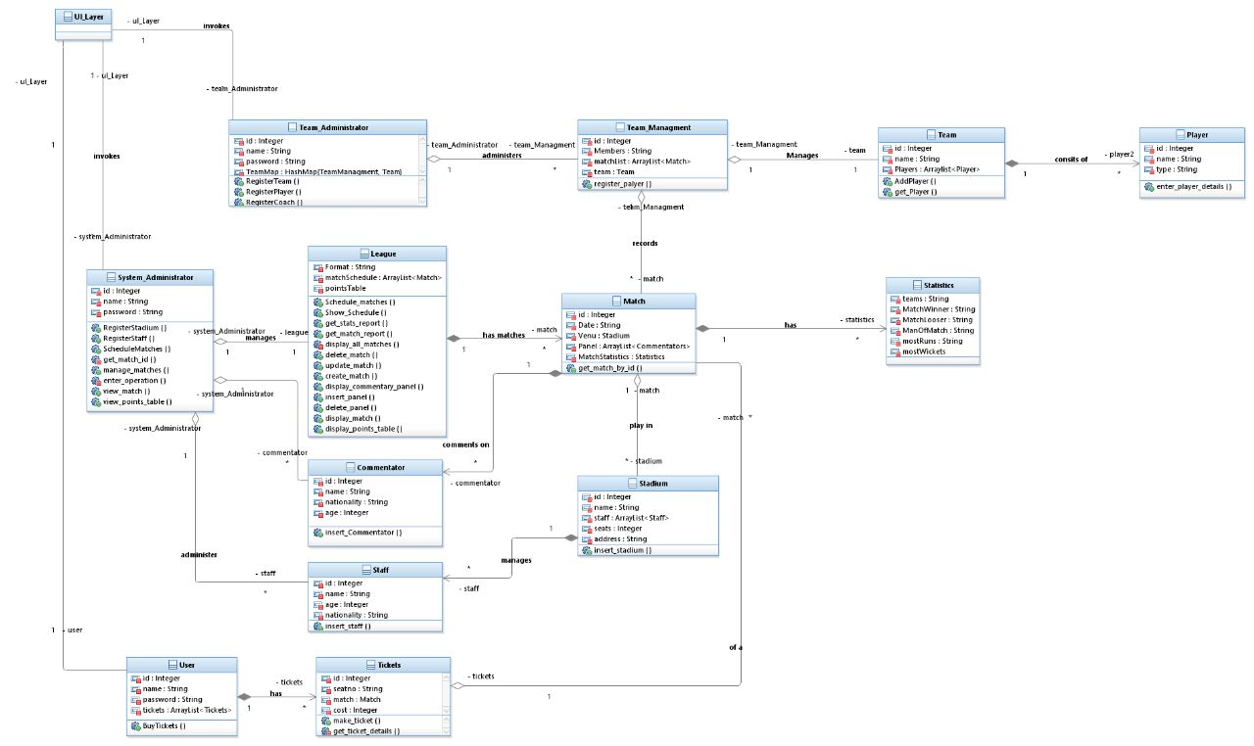

## Package Diagram

